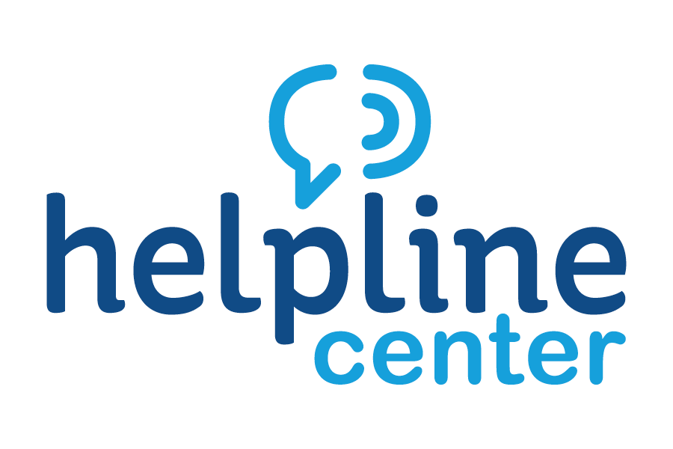
April Volunteer of the Month Celebrated

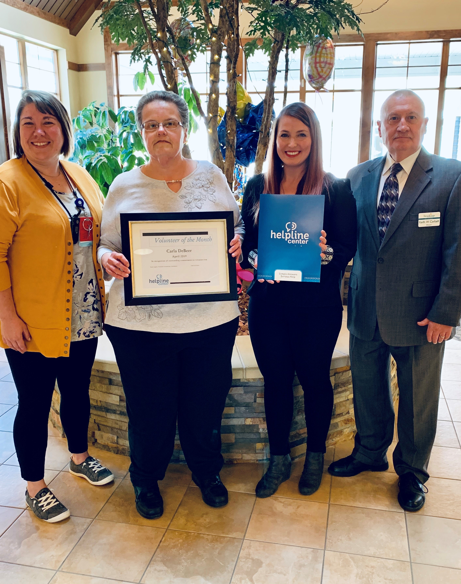
L to R: Jessie Kuechenmeister, Activities Assistant at The Neighborhoods at Brookview; Carla DeBeer, Volunteer of the Month; Sarah Lippert, Volunteer Connections Coord. with Helpline Center and Keith Corbett, Mayor of Brookings

The Helpline Center congratulates Carla DeBeer on being named the April 2019 Volunteer of the Month, an area-wide award program sponsored by the Helpline Center.

There to honor and celebrate Carla were Keith Corbett, Mayor of Brookings; Jessie Kuechenmeister, Activities Assistant at The Neighborhoods at Brookview; and Sarah Lippert, Volunteer Connections Coordinator for the Helpline Center.

Carla has been volunteering at The Neighborhoods at Brookview for approximately 5 years. Carla volunteers at least once a week, sometimes more depending upon activities.

Carla assists with a variety of events at The Neighborhoods at Brookview. When we have BINGO, she arrives early and helps pass out drinks and popcorn to our residents. And then calls BINGO. She gets to know the residents (and their families) and interacts with them, adding humor and fun to the BINGO game. Carla assists with all community outings. Once again, arriving early and staying until the activity is completed. She makes sure the residents needs are met and they have an enjoyable time. Carla volunteers to help on holidays, providing assistance where needed. Each winter Carla donates approximately 10 handmade afghans that are sold with the profits being donated to the resident activity fund. Carla also is a resource and provides guidance to new volunteers!

Carla should win the Volunteer of the Month award because she routinely goes above and beyond to make a positive difference in the lives of our residents and their family members. Carla is consistent, invested, and genuinely caring. She contributes her time and her talents and makes a positive impact in the lives of other people.

Congratulations, Carla, on being our much-deserved April Volunteer of the Month!

For information on volunteer opportunities or the Volunteer of the Month program, please contact Sarah Lippert at bkvol@helplinecenter.org or call 211 for more information.

