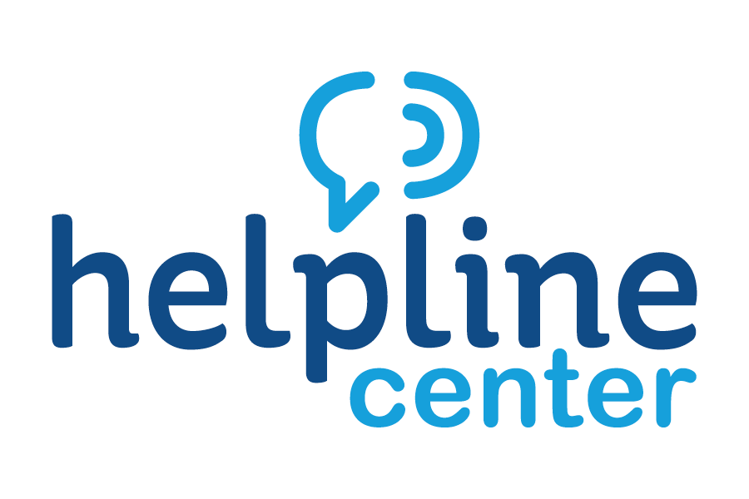
August Volunteer of the Month Celebrated



L to R: Heidi Gullickson, Executive Director at Brookings Area United Way; Keith Corbett, Mayor of the City of Brookings; Ellen Herrboldt, August Volunteer of the Month and Sarah Lippert, Helpline Center Volunteer Connections Coordinator

The Helpline Center congratulates Ellen Herrboldt on being named the August 2018 Volunteer of the Month, an area-wide award program sponsored by the Helpline Center and Dakotaland Federal Credit Union.

There to honor and thank Ellen were Heidi Gullickson, Executive Director of the Brookings Area United Way; Keith Corbett, Mayor of the City of Brookings; Brianna Doran, Executive Assistant of the Brookings Area United Way; and Sarah Lippert, Volunteer Connections Coordinator at Helpline Center.

Ellen has been a consistent volunteer with United Way for several years. “She is our go to person for the Delta Dental Mobile Program. She is always willing to help and is a friendly face for the families that she is interacting with. She is organized and communicates well with everyone involved.” says Heidi Gullickson, United Way Executive Director

Not only is she a volunteer for United Way, but also very involved in other activities in the community; including Brookings Summer Arts Festival and the VFW. Ellen was also an active RSVP volunteer for 6 years where she logged 3,000 hours!

The time, commitment, and energy that Ellen brings to the organizations that she volunteers with is quite evident through the smiles and the appreciation of the families, children and individuals that she helps serve.

Ellen does not consider herself simply a volunteer in the Brookings Community; she is a friend to all those she encounters! Congratulations, Ellen, on being our much-deserved August Volunteer of the Month.

For information on volunteer opportunities or the Volunteer of the Month program, please contact Sarah Lippert at bkvol@helplinecenter.org or call 211 for more information.

