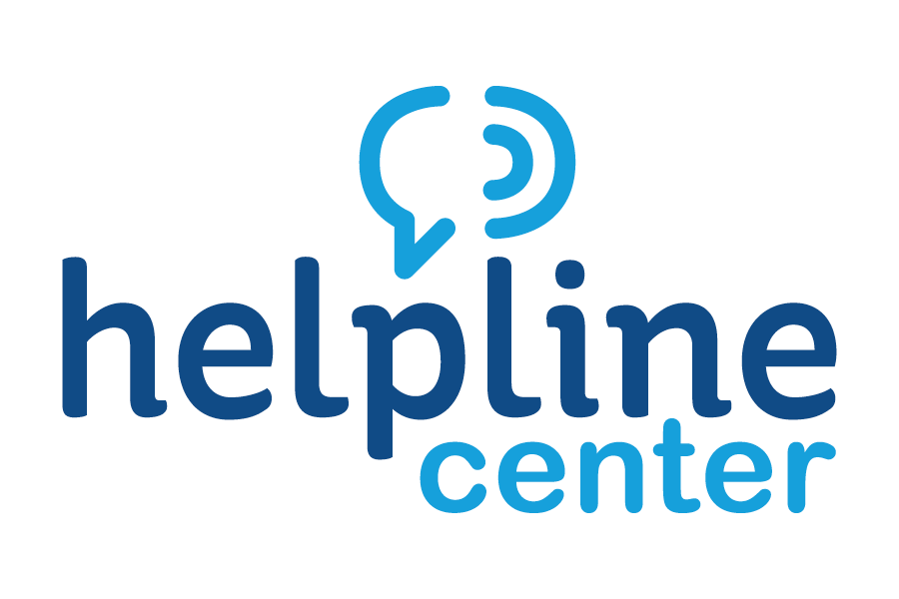
January Volunteer of the Month Celebrated

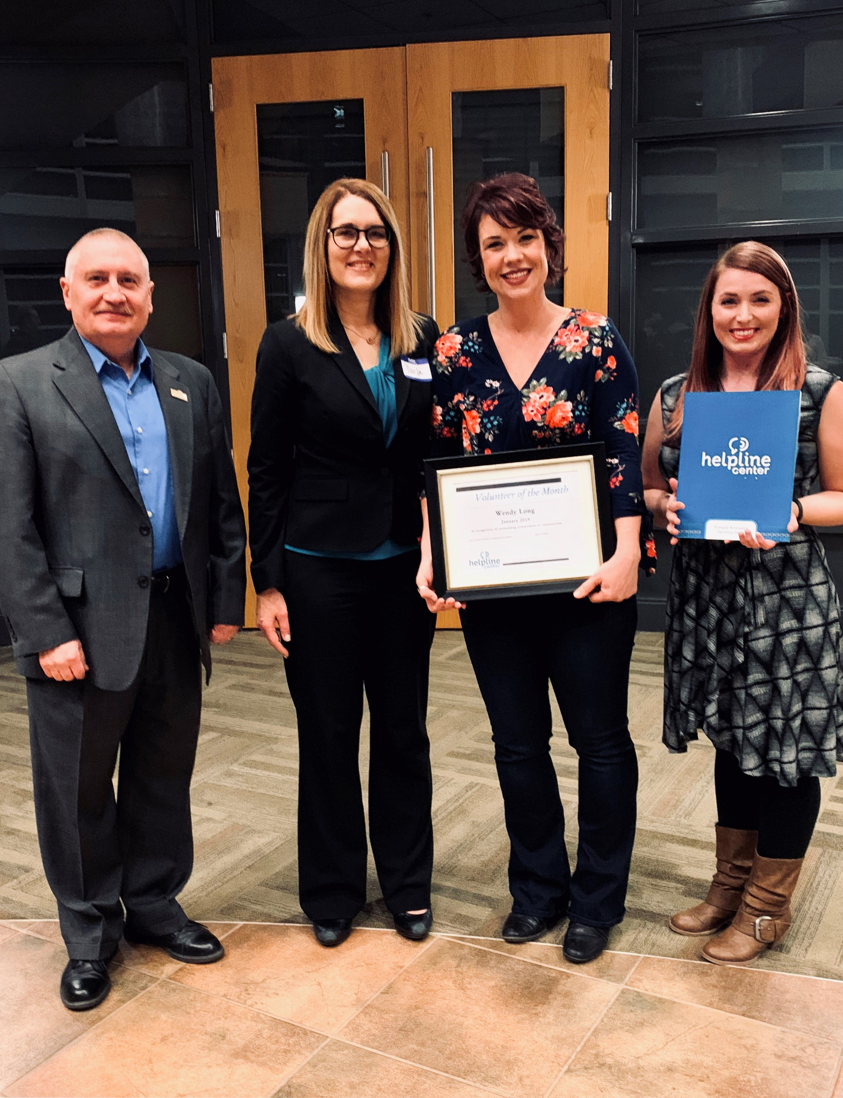

Picture from L to R: Keith Corbett, Mayor of the city of Brookings; Darla Biel, Exec. Dir. Of Brookings County Youth Mentoring Program; Wendy Long, Volunteer of the Month; and Sarah Lippert, Volunteer Connections Coordinator at Helpline Center

The Helpline Center congratulates Wendy Long on being named the January 2019 Volunteer of the Month, an area-wide award program sponsored by the Helpline Center.

There to honor and thank Wendy were Darla Biel, Executive Director of the Brookings County Youth Mentoring Program; Keith Corbett, Mayor of the City of Brookings; Sarah Lippert, Volunteer Connections Coordinator at Helpline Center and numerous Brookings County Youth Mentoring Program Board Members.

Wendy had volunteered as a BCYMP Mentor while she was a student at SDSU. Subsequently, she served for 9 years on the BCYMP Board of Directors. She is Past-President and had been the Chair of the Fundraising Committee for several years when she finished her third 3-year term on the board and chose to not take a 4th term because she is going to nursing school. However, she is still a current and active member of the Fundraising Committee.

Darla Biel states “Wendy is a creative, passionate and dedicated volunteer who generously shares her time with BCYMP even though she is a busy mom, wife, student and EMT. Some of BCYMP's most creative ideas originated with Wendy. For example, she was the one who designed and sewed our "Linc" costume for the fall #BCYMPPennyWars fundraiser”.

Congratulations, Wendy, on being our much-deserved January Volunteer of the Month!

For information on volunteer opportunities or the Volunteer of the Month program, please contact Sarah Lippert at bkvol@helplinecenter.org or call 211 for more information.

