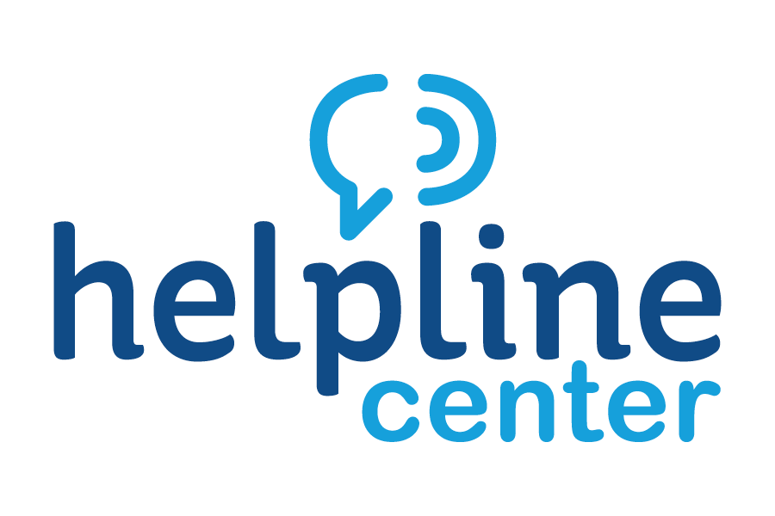
September Volunteer of the Month Celebrated

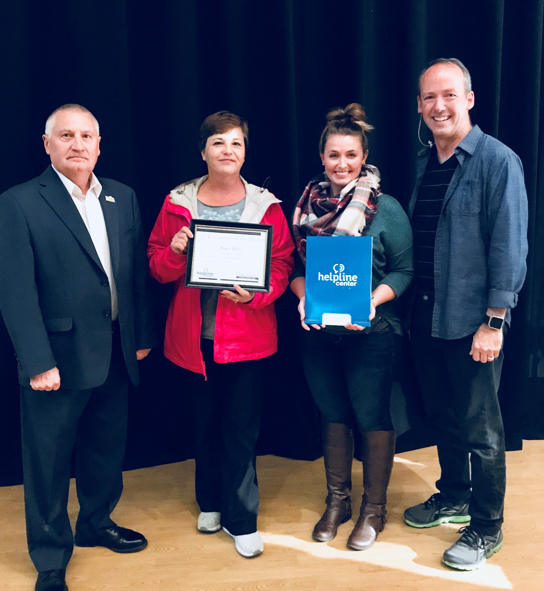
Picture from L to R: Keith Corbett, city of Brookings Mayor; Angie Daly, Volunteer of the Month; Sarah Lippert, Volunteer Connections Coordinator at Helpline Center; Pastor Wade Miller, Lead Pastor at Brookings First United Methodist Church

The Helpline Center congratulates Angie Daly on being named the September 2018 Volunteer of the Month, an area-wide award program sponsored by the Helpline Center.

There to honor and thank Angie were Pastor Wade Miller, Lead Pastor at
Brookings First United Methodist Church; Keith Corbett, Mayor of the City of Brookings; Sarah Lippert, Volunteer Connections Coordinator at Helpline Center; and numerous congregation members at Brookings First United Methodist Church.

Angie has been very active in helping plan and coordinate special events and our weekly worship meal. This June, she helped lead our "Pie and Lattes" Neighborhood Block Party with homemade pie, music, fun and games for over 100 church members and friends.

Through the school year, Angie has been very helpful in coordinating our volunteers and working with our part-time cook to feed 150 youth and their families each and every Wednesday. She has been instrumental in setting up, working with volunteers, serving, and doing everything necessary to make sure our families have a place each week to sit around the table together, share in worship and fellowship with friends and other church families, and catch their breath with a nutritious, but simple, meal.

Angie has a great personality and spirit. She volunteers where she can, tells us "no" when she can't, and always has a glad heart. We are truly blessed to have her be a part of our church family.

Congratulations, Angie, on being our much-deserved September Volunteer of the Month.

For information on volunteer opportunities or the Volunteer of the Month program, please contact Sarah Lippert at bkvol@helplinecenter.org or call 211 for more information.

